The importance of upper air measurements on the lower air

Karim El-Sharkawy

EAPS 22700 Lab 3

24th October 2021

Introduction:

There are multiple reasons why we care about what happens in the upper troposphere. As with many things like science, mathematics, and engineering, what happens in one place, although it may seem unrelated, affects another place. Learning about one will help us understand the other and why it does what it does. So, learning about the conditions in the upper troposphere and caring about them helps us understand our conditions down here on the surface (because the atmosphere is a fluid). Learning about the upper troposphere also can help us predict future events in the lower troposphere. By extension, this in itself can help us be more prepared, and better our standards of living. For example, this affects things like aviation, storm formation, etc.

The three hypotheses we tested were:

1. Convective thunderstorms are likely to form in the environment represented by the 11 October 2021 sounding.

2. Supercells are likely to form in this environment.

3. Tornadoes are likely to form in this environment

Instruments:

Similar to our last lab, we used Kestrel 5400 Heat Stress Trackers to record temperatures and wind speed. Taken from my second lab report: “According to the manufacturer, The measurements of the Kestrels have an accuracy of 0.9℉ or 0.5C℃(Nielsen-Kellerman Co., 2020: Kestrel 5400 Heat Stress Trackers: Certificate of Conformity. Page 2)” (El-Sharkawy, K. 2). The Windsond that we used was an S1H3 Extra accuracy humidity sensor. It has a capacitive humidity sensor with an accuracy of 1.8% RH and a resolution of 0.05% RH. It also has a bandgap temperature sensor with an accuracy of 0.2°C and a resolution of 0.01°C (Sparv p.4). This Windsond was used with a BA20 latex Balloon with a BL140 lithium-ion Battery (Sparv p.5) and RR1-250 Radio receiver (Sparv p.7). The type of software we used is unknown. I did not get that information from Professor Robin Tanamachi. It’s important to note that this data was taken on the 11th of October, 2021.

Methods:

The data was recorded on a computer. The instruments were all used outside in the “Oval”. An oval-shaped space about 1-2 minutes walking from Stanley Coulter. The data was recorded on a computer via USB. The sonde would send data to the computer until the it finally stopped sending data, then the data would be interpreted and graphed on the computer.

Data:

**Table 1: Relation of pressure with temperature and dew point from sonde data**

| Mandatory Levels (mb) | Closest pressure (mb) available | Temperature (°C) | Dew point temperature (°C) |
| --- | --- | --- | --- |
| Surface | 986.60 | 25.00 | 19.00 |
| 925 | 925.06 | 19.84 | 15.79 |
| 850 | 850.76 | 16.99 | 9.58 |
| 700 | 700.62 | 7.80 | -6.56 |
| 500 | 500.26 | -8.39 | -26.56 |
| 400 | 400.29 | -17.15 | -39.38 |
| 300 | 300.19 | -33.03 | -52.26 |
| 250 | 250.26 | -41.91 | -55.23 |
| 200 | 200.17 | -46.24 | -57.98 |

The FL, CCL, Tc, LCL, LFC, EL, CIN, and CAPE are all in Appendix A in the “Citations” category.

Calculations:

Lifted Index: LI = T500 - T’

T500 -8.4°C

T’ = -5.15°C

**LI = -8.4 - (-5.15) = -3.25°C (Moderate weather potential)**

Showalter Stability Index: SSI = T500 - T’

T500 -8.4°C

T’ = -10.5°C

**SSI = -8.4 - (-10.5) = 2.1°C (Rain showers, some thundershowers)**

**Note: I drew the new LCL in Appendix A. It’s labeled as “LCL 2”**

K index = (T850 - T500) + Td850 - (T700 - Td700)

T850 = 17.0°C

T500 = -8.30°C

Td850 = 9.00°C

T700 = 7.00°C

Td700 = 7.00°C

**K index = (17.0 - (-8.30)) + 9.00 - (7.00 - 7.00) = 34.30°C**

TT = (T850 + Td850) - (2 * T500)

T850 = 17.0°C

Td850 = 9.00°C

T500 = -8.30°C

**TT = (17.0 + 9.00) - (2*(-8.30)) = 26.0 + 16.60 = 42.6°C (not on the chart, less than thunderstorms)**

SWEAT = 12(850Td) + 20(TT - 49) + 2(V850) + (V500) + 125(sin(dd500 - dd850) + 0.2)

Since my TT is less than 49, so the entire expression will be set to 0 in this equation.

Td850 = 9.00 °C

V850 = 38.46 kt

V500 = 63.92 kt

dd500 = 203.28 kt

dd850 = 198.38 kt

**SWEAT = 12(9.00 °C) + 0 + 2(38.46kt) + 63.92kt + 125(sin(203.28 - 198.38) + 0.2) = 108°C + 176.5171 kt = 284.5171 (Slight Severe)**

From these numbers, it’s unlikely that convective thunderstorms would form in the environment sampled because Lifted Index, SSI, K-Index, and TT all suggest the opposite. All the equations above were retrieved from a Meted Module (COMET MetEd lesson 225). The CAPE also has an effect on this, however, I will explain in my discussion why my specific region of CAPE is not a good drawing.

**Table 2: Sonde data showing recorded wind direction, wind speed, and altitude (in km AGL).**

| Altitude (km above ground level) | Wind Direction (°) | Wind Speed (kt) |
| --- | --- | --- |
| Surface | 125.00 | 2.60 |
| 0.5 | 170.65 | 23.96 |
| 1.0 | 182.10 | 28.77 |
| 2.0 | 193.11 | 40.29 |
| 3.0 | 191.22 | 46.24 |
| 4.0 | 193.19 | 54.42 |
| 5.0 | 194.09 | 54.17 |
| 6.0 | 202.65 | 66.44 |
| 8.0 | 199.31 | 59.10 |
| 10.0 | 198.89 | 41.69 |
| 12.0 | 213.17 | 48.49 |

Note: For hodographs, altitude is taken as km AGL. We converted to MSL which in our case, is MSL = AGL + 200m. In the hodograph, the AGL is used instead.

The 0-6 km bulk shear vector is approximately 63.84 kt in length (strong supercells likely) and the 0-1 km bulk shear vector is approximately 26.17 kt in length (Tornados more likely).

Based on two bulk shear vectors alone, strong supercells and tornados are likely to form because they go above the values that indicate what types of supercells and tornados will form. For example, for a strong supercell to form, a value of 40 kts has to be achieved. The 0-6 km bulk shear vector has a length of 63.84 kt.

Figure 1: Hodograph with data points from sonde data (Hodograph p.1)

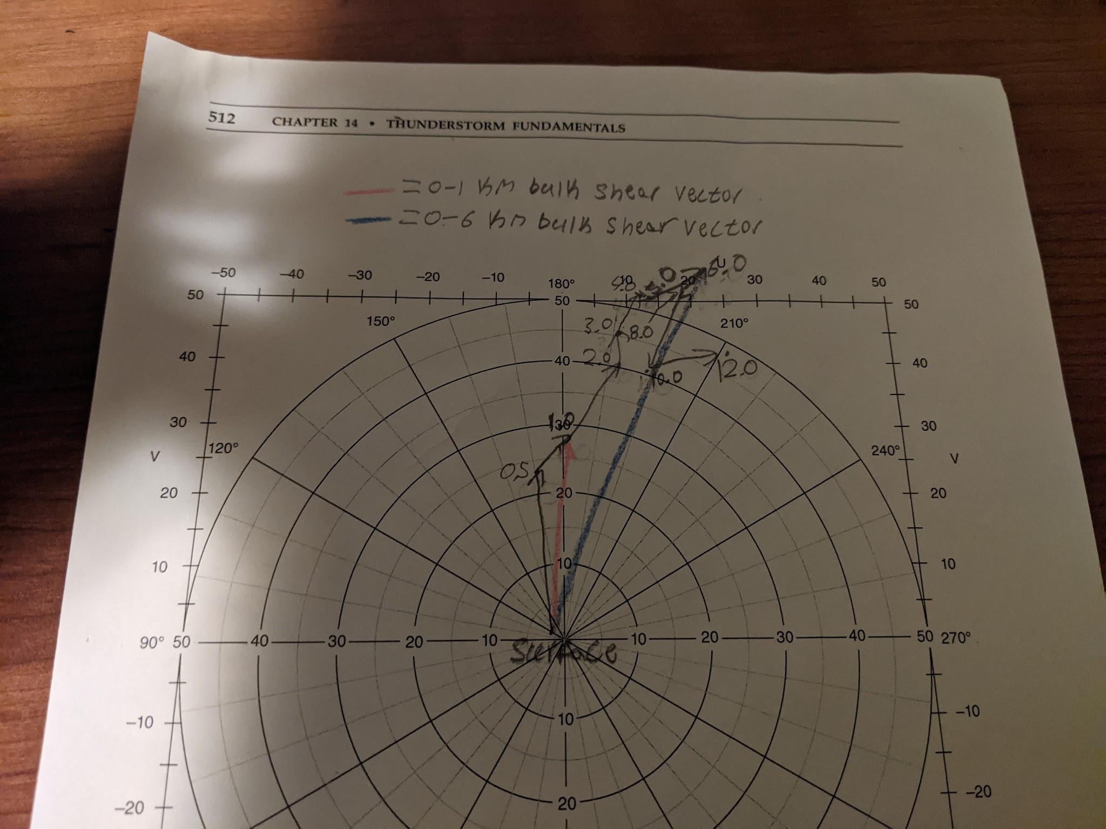

To draw the hodograph, I used a MetEd module (COMET MetEd Lesson 136) and my professor’s lectures to draw the points and the shear vectors.

Discussion:

Looking at the 3 hypotheses again, it seems that hypothesis 1 is incorrect. Hypotheses 2 and 3 are a little misleading, but I also believe them both to be incorrect. They are misleading because while the shear vectors were large in magnitude, they don’t have much rotation which wouldn’t allow for a high likelihood of supercell formation. While the shear vectors had large magnitudes, basing what will happen in the atmosphere on these two values (0-1 km and 0-6 km shear vectors) alone will give us an inaccurate view of the atmosphere. There are multiple factors to everything, like the values calculated earlier in the calculations section, and the low amount of CAPE in Appendix A (Appendix A). These two actually go against what the two bulk vectors are indicating. Finally, since this was done live, I can give my testimony that there were clearly no large supercells or any real indications of tornados. As said in the data section: “It’s unlikely that convective thunderstorms would form in the environment sampled because Lifted Index, SSI, K-Index, and TT all suggest the opposite” (page 5). The Lifted Index, SSI, K-Index, and TT have values that are too low to suggest any of the hypotheses would be true. Some problems with this procedure might change the results a little, however, they would still affirm that the hypotheses are incorrect. When drawing the line from LCL and following the moist adiabats, the hand-drawn line was moved slightly to the right to match the moist adiabat more properly. This exaggerates the amount of CAPE present and slightly changes the equilibrium level in Appendix A. However, this would lower the CAPE and therefore, would only affirm that the hypotheses are incorrect.

Conclusion:

In conclusion, using Appendix A and hodographs, the three original hypotheses that it’s likely for convective thunderstorms, supercells, and tornados to form have been refuted. This shows the significance of upper air measurements on lower air measurements. It’s important to understand that everything affects everything else. This can’t be any more true than for an atmosphere. The atmosphere is like the human body. If an event happens in one part of the body, it affects the other part of the body.

**Bibliography**

1. COMET. (2006, October 4). *COMET / MetEd Lesson Viewer*. COMET MetEd. Retrieved October 18, 2021, from https://www.meted.ucar.edu/education_training/lesson/225
2. COMET MetEd. (2003, October 28). *COMET / MetEd Lesson Viewer*. Retrieved October 24, 2021, from <https://www.meted.ucar.edu/education_training/lesson/136>
3. Sparv Embedded AB, 2019: Windsond Product Catalogue pages 4,5, and 7
4. El-Sharkawy, K. (2021). The effects of shade on temperature measurements. In R. Tanamachi (Ed.), *The effects of shade on temperature measurements* (p. 2). Karim El-Sharkawy.
5. El-Sharkawy, K. (2021a). Appendix A. In *Appendix A* (pp. 1–3). Karim El-Sharkawy.
6. El-Sharkawy, K. (2021b). Hodograph. In *Hodograph* (pp. 1–5). Karim El-Sharkawy.